|  |
| --- |
| **artbin: evaluation of sample size and power in randomized controlled trials with a binary outcome (STATA program).**  **Compared with**  **EAST software (Cytel). Design: Discrete Endpoint, Two-sample test, Parallel design, Difference of proportions [PN-2S-DI].** |

|  |  |  |  |  |  |  |  |
| --- | --- | --- | --- | --- | --- | --- | --- |
| Reviewer ........................EMZ |  | |  | | | | |
| Review date 08/11/2020. Latest: 13/06/2022. | |  | |  | | |  | |  |
| Artbin version 2.0.1 |  | |  | |  |  | |

Work overview

A Stata Program was created to calculate sample size and power in trials with binary outcome, named artbin. artbin is able to handle multi-arm trials and unequal allocation ratios.

The output of artbin will be compared to Cytel’s online package EAST which is sophisticated software able to produce sample size and power calculations for a range of binary outcomes in clinical trial settings.

Please note that EAST input screen shots for each example are included at the end of the document.

*Testing: Sample size*

| **Trial** | **Outcome** | **Parameters (α one-sided unless otherwise stated (*))** | **EAST**  **n** | | **artbin code** | | | **artbin result**  **n** | |  | |
| --- | --- | --- | --- | --- | --- | --- | --- | --- | --- | --- | --- |
| 1. Non-inferiority | Binary | p = 90%, d = 20%, α = 5%, β = 10% | | **78** | artbin, pr(0.1 0.1) margin(0.2) alpha(0.1) power(0.9) wald | | | | **78** |  |
| 1. Non-inferiority | Binary | p = 70%, d = 10%, α* = 5%, β = 20% | | **660** | artbin, pr(0.3 0.3) margin(0.1) alpha(0.05) power(0.8) wald | | **660** | | |  | |
| 1. Non-inferiority | Binary | p = 70%, d = 5%, α = 2.5%, β = 10% | | **3531** | artbin, pr(0.3 0.3) margin(0.05) alpha(0.05) power(0.9) wald | | **3532** | | |  | |
| 1. Non-inferiority | Binary | p = 85%, d = 15%, α* = 5%, β = 10% | | **239** | artbin, pr(0.15 0.15) margin(0.15) alpha(0.05) power(0.9) wald | | **240** | | |  | |
| 1. Non-inferiority | Binary | p = 80%, d = 10%, α = 10%, β = 20% | | **289** | artbin, pr(0.2 0.2) margin(0.1) alpha(0.2) power(0.8) wald | | **290** | | |  | |
| 1. Non-inferiority | Binary | p = 90%, d = 5%, α = 2.5%, β = 10% | | **1514** | artbin, pr(0.1 0.1) margin(0.05) alpha(0.05) power(0.9) wald | | **1514** | | |  | |
| 1. Non-inferiority | Binary | p = 75%, d = 20%, α = 2.5%, β = 10% | | **198** | artbin, pr(0.25 0.25) margin(0.2) alpha(0.05) power(0.9) wald | | **198** | | |  | |
| 1. Non-inferiority | Binary | p = 80%, d = 15%, α = 2.5%, β = 10% | | **299** | artbin, pr(0.2 0.2) margin(0.15) alpha(0.05) power(0.9) wald | | **300** | | |  | |
| 1. Non-inferiority | Binary | p = 85%, d = 5%, α = 2.5%, β = 10% | | **2144** | artbin, pr(0.15 0.15) margin(0.05) alpha(0.05) power(0.9) wald | | **2144** | | |  | |
| 1. Non-inferiority | Binary | p = 90%, d = 2.3%, α = 2.5%, β = 10%, ar(1:2) | | **8045** | artbin, pr(0.9 0.9) margin(-0.023) alpha(0.05) power(0.9) wald ar(1 2) | | **8046** | | |  | |
|  |  |  | |  | |  | | |  |  | |

**EAST Screen shots and artbin outputs**

*Example 1*

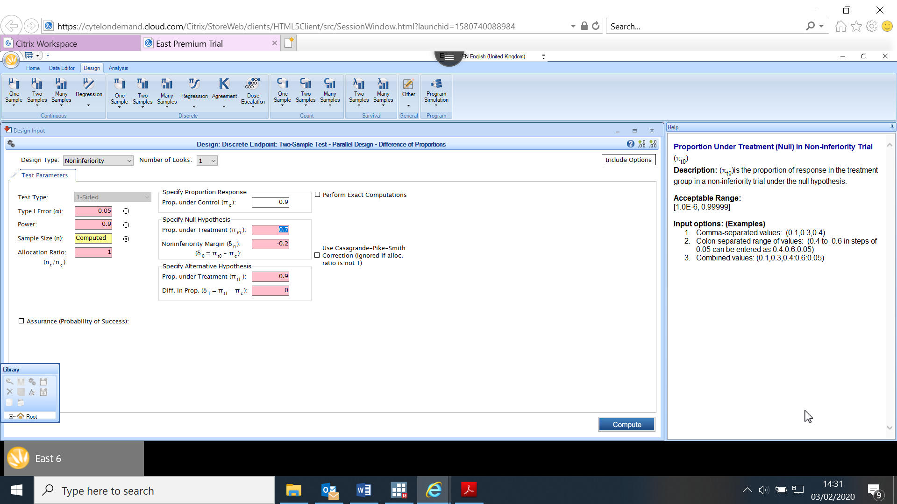

*Example 2*

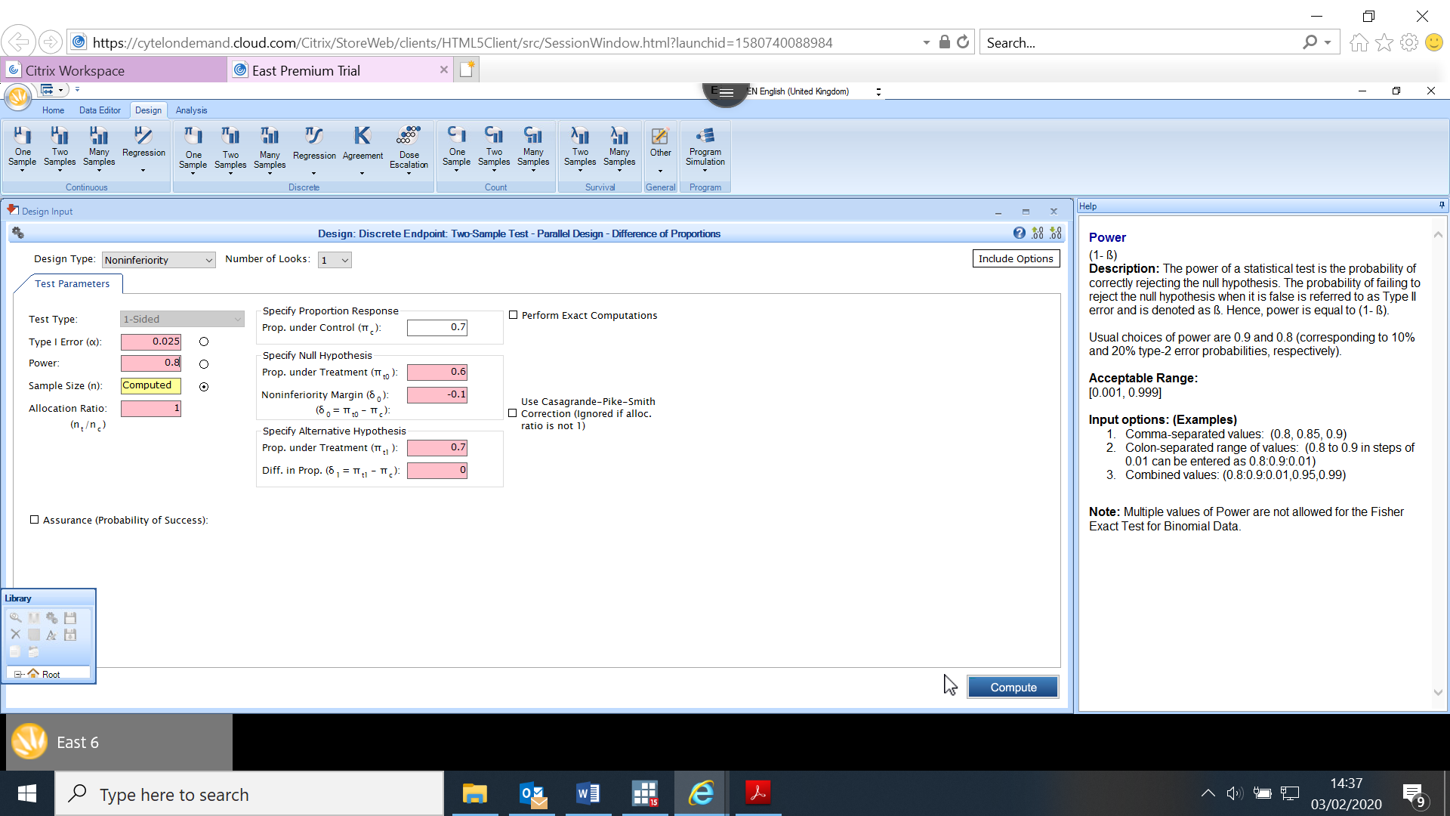

*Example 3*

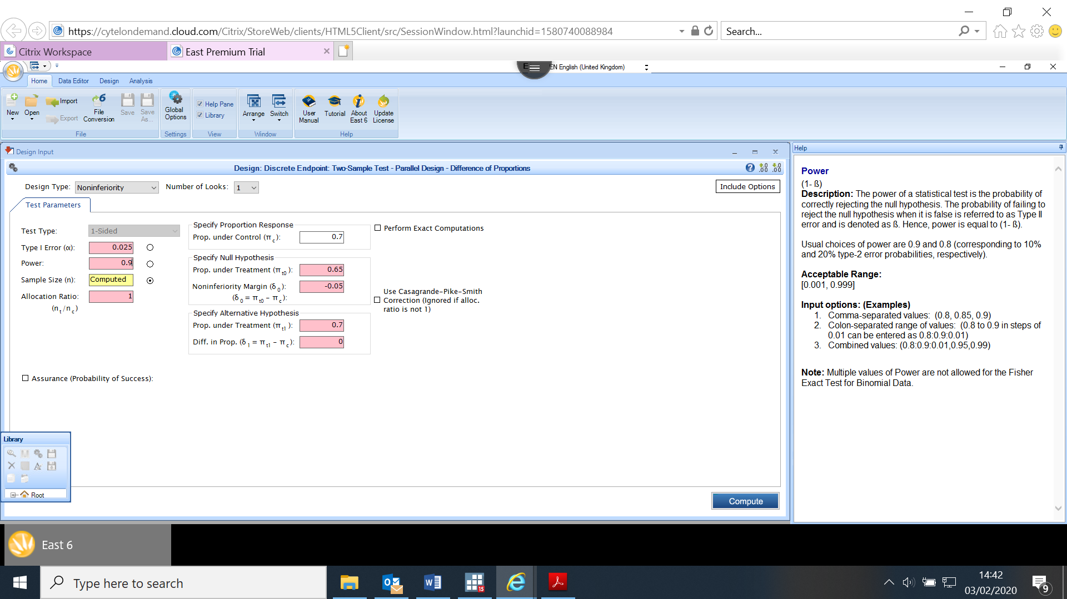

*Example 4*

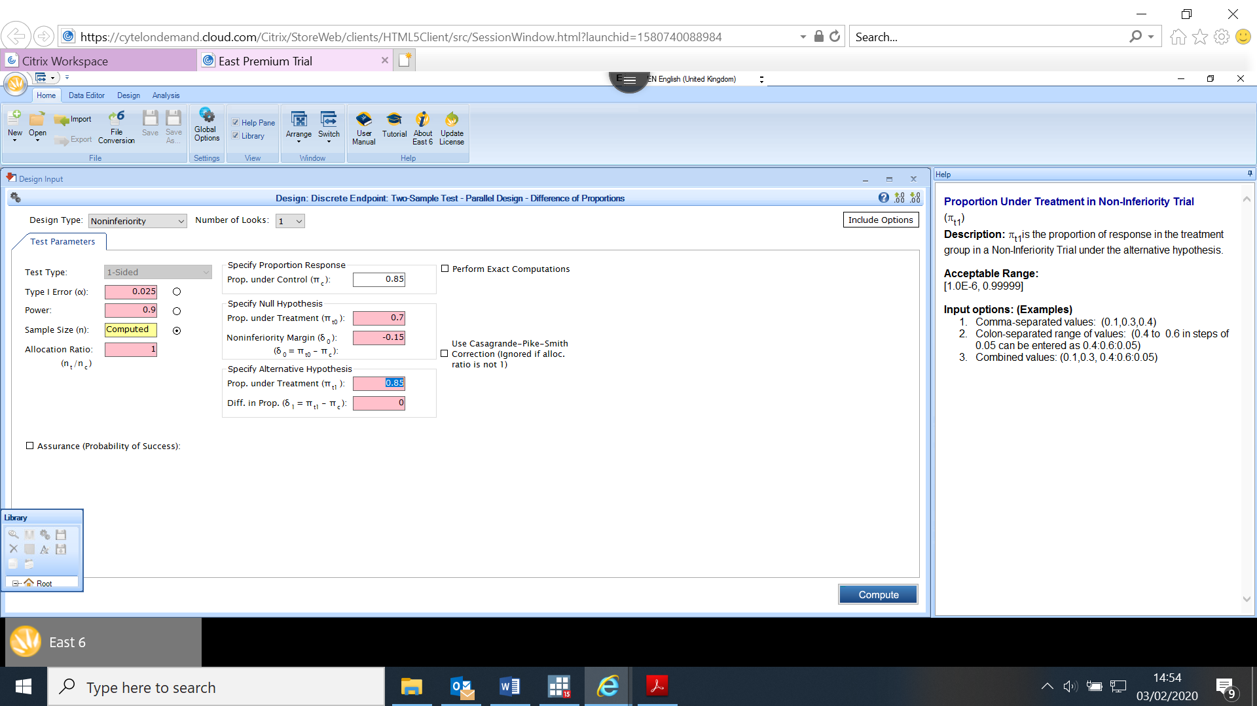

*Example 5*

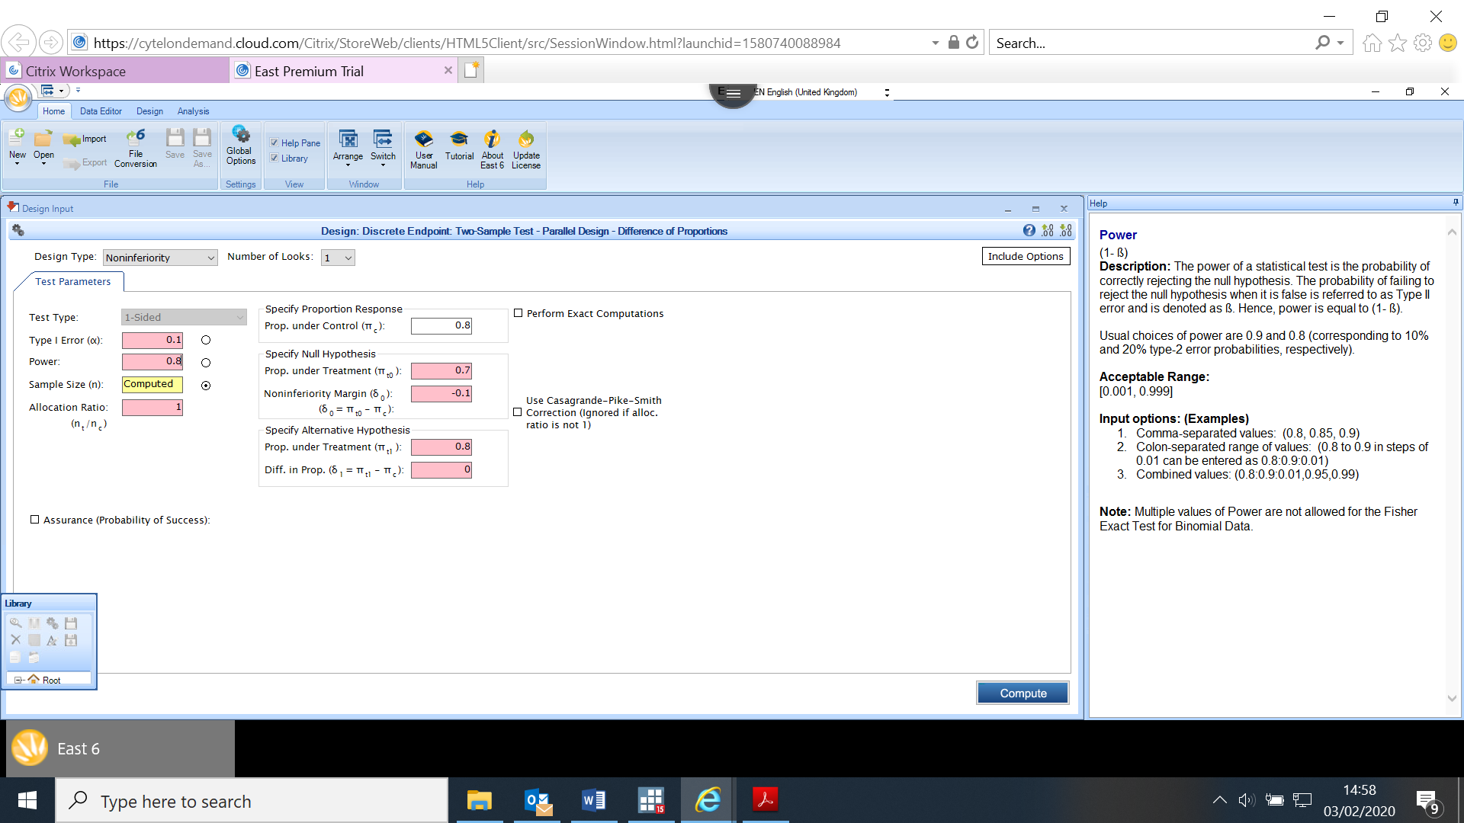

*Example 6*

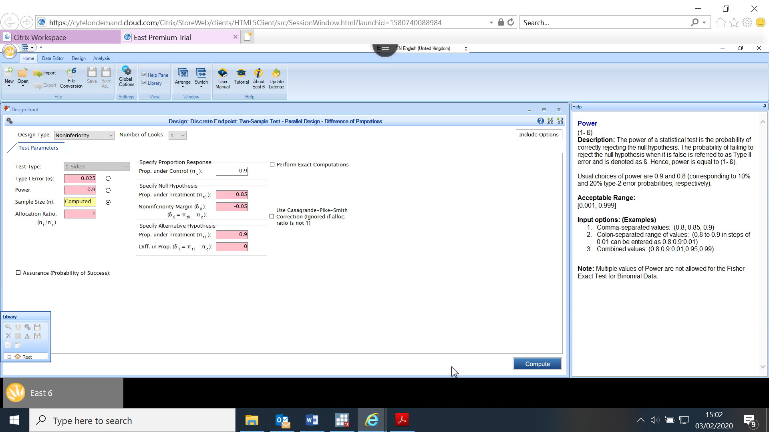

*Example 7*

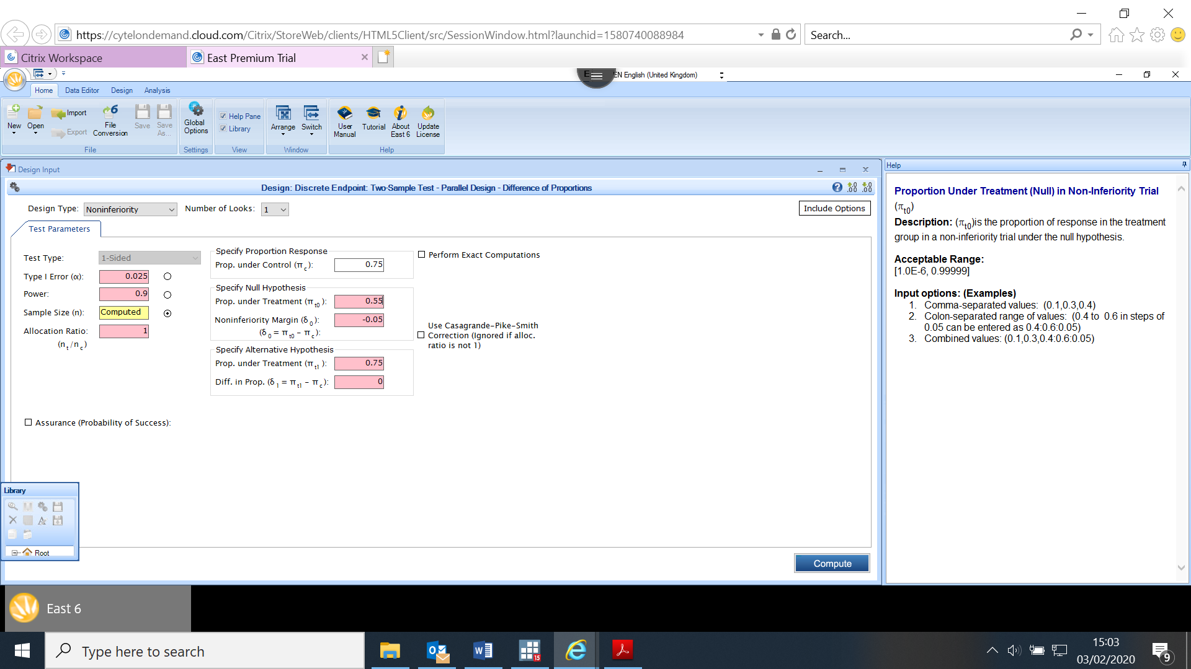

*Example 8*

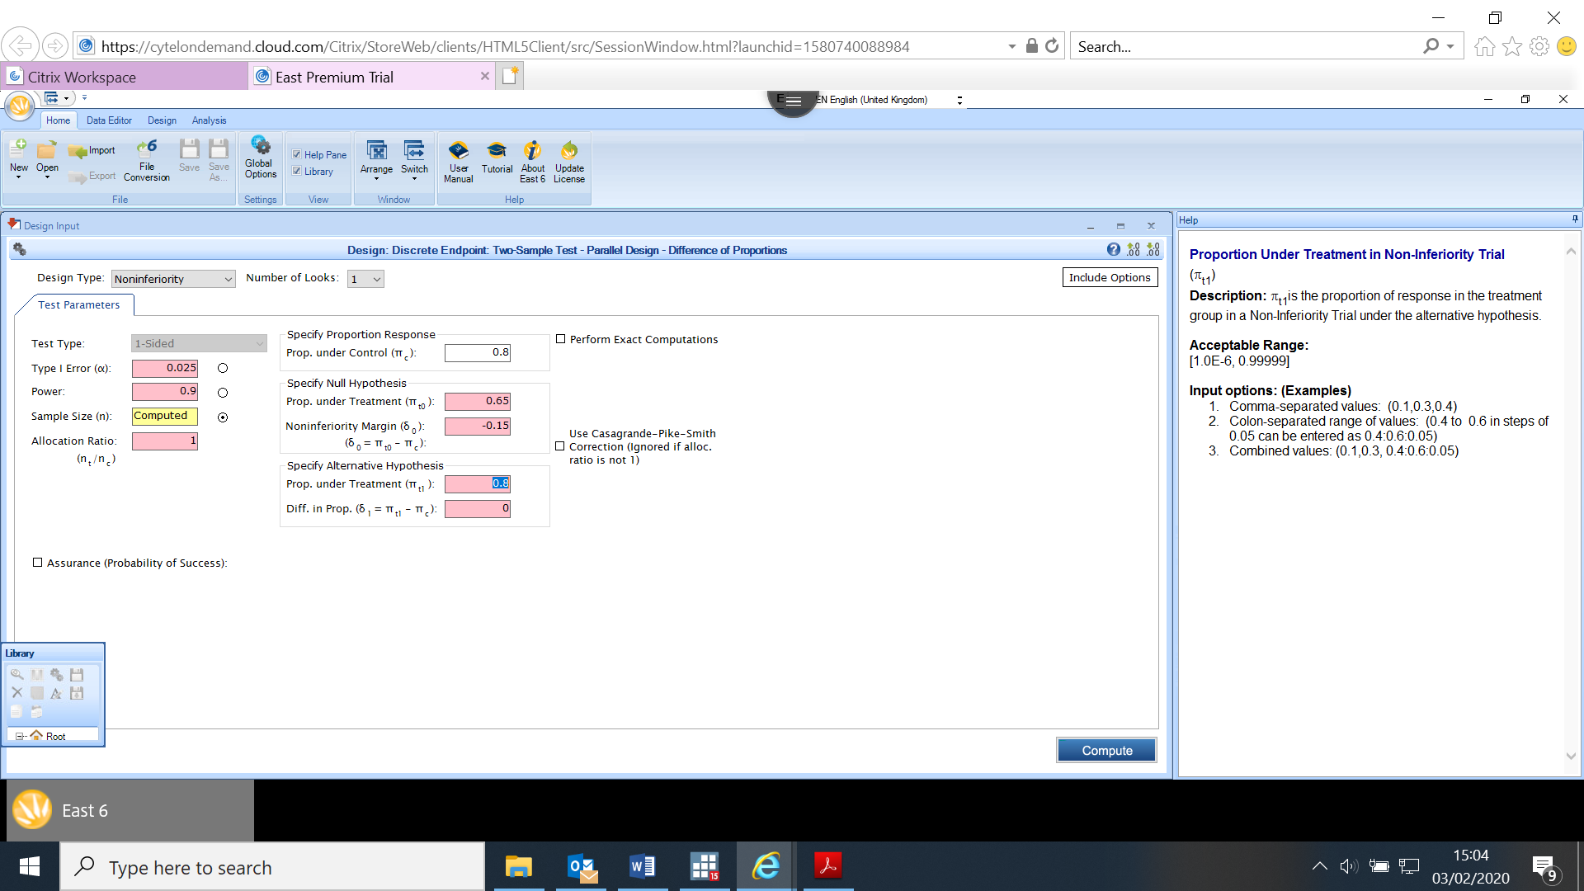

*Example 9*

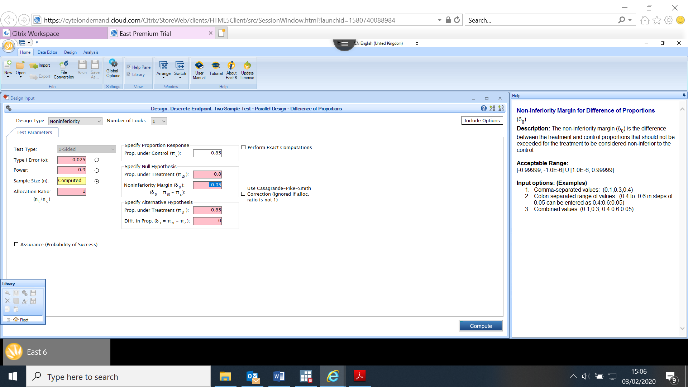

*Example 10*

